Student ID: 2400090136
Name:MADDA HARSHAVARDHAN REDDY
Skill Experiment Number: Skill-12
Section Number: 56

TITLE: Full-Stack CRUD Application using React & Spring Boot
CODE:
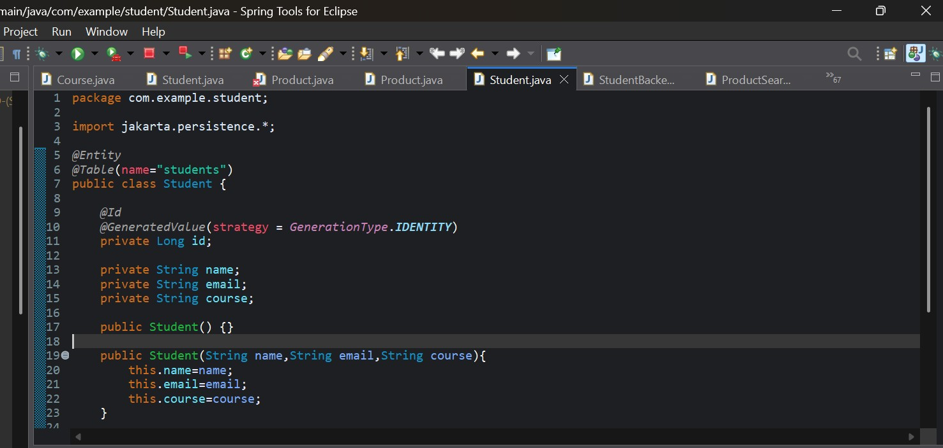
OUTPUT:
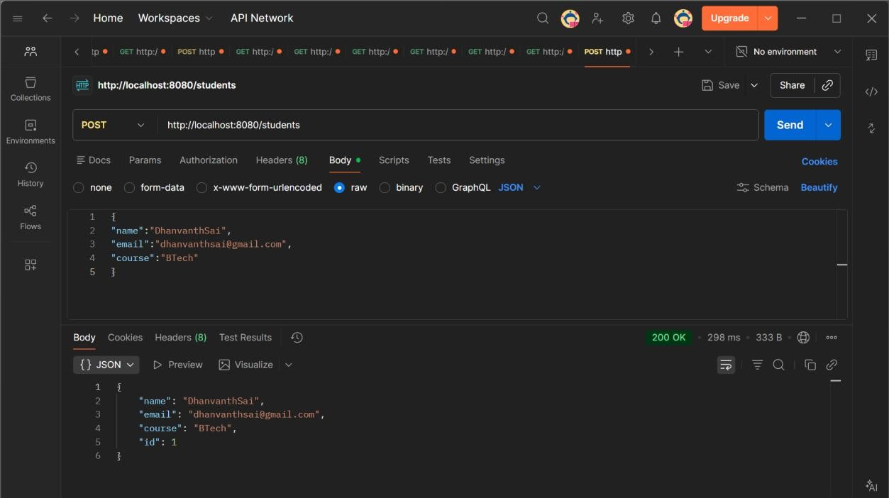
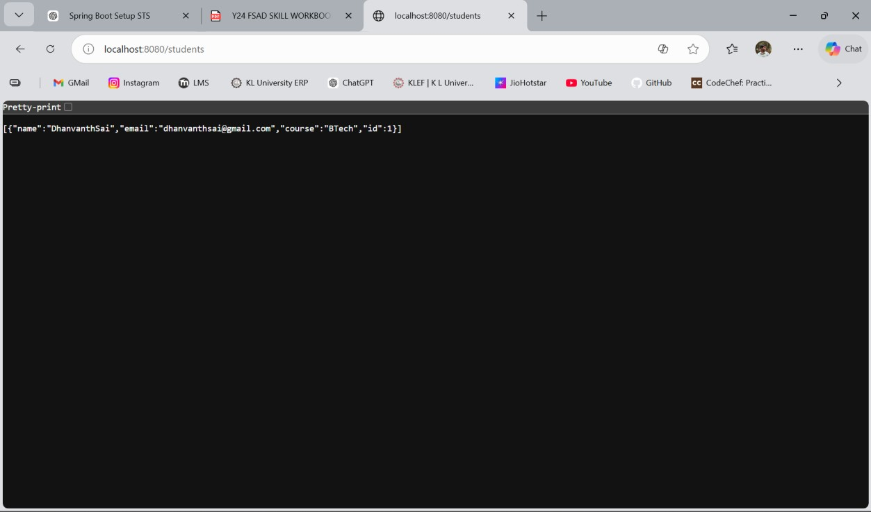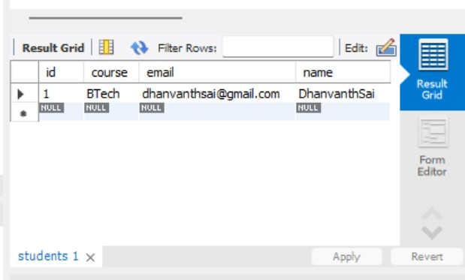
GitHub Repository Link: dhanvanthsaimadamanchi/student-backend-Skill-12-

